# Introduction

Hello everyone and welcome to a quick overview of my final project

for the doing data science class in the master in data science program at SMU

# Agenda



For this assignment we were given an employee dataset by FritoLay and ask to do the following:

* Identify the three most important factors for Employee Attrition
* As well as build a Knn or Naïve model to predict attrition
* Build a linear regression model for predicting employee salary
* Providing insight in job role specific trends

Without further due let’s star talking about the data

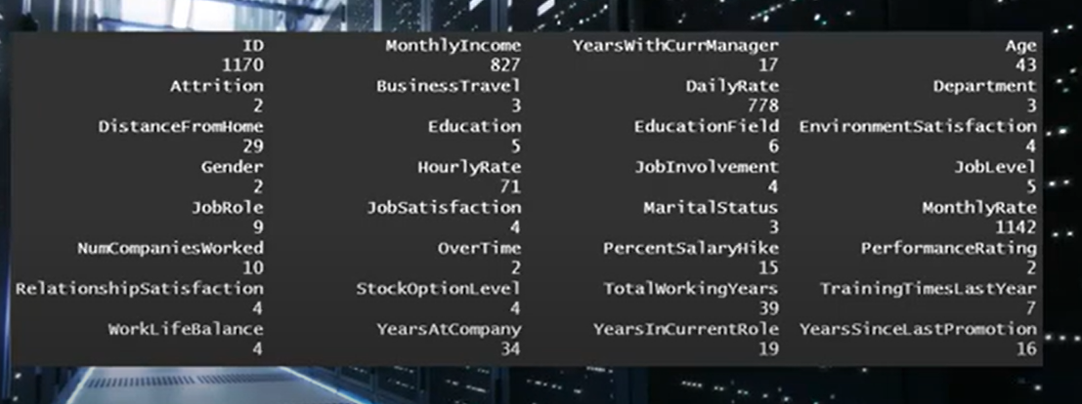



I wanted to run both Naïve Bayes and I really wanted to run a lot of test

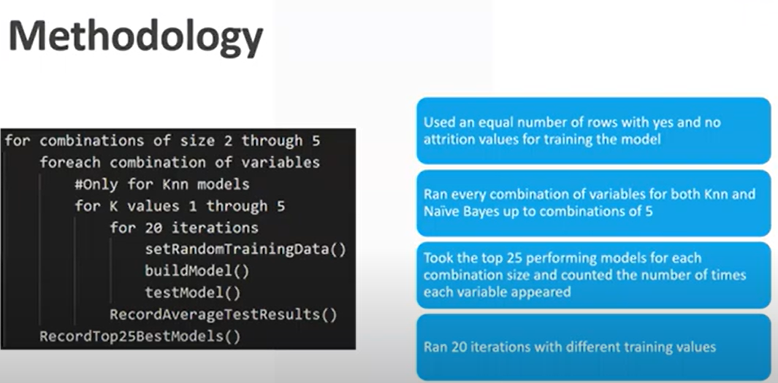

* The modeling process
* Run the model
* Run a lot of tests
* I took all the different combinations of variables I could
* For each combination of variable I took 20 iteration
* I took all the different values of K
* I set random training data, I built the model, and tested the model
* I recorded the average test results of those 20 iteration
* And I took the 25 best models for KNN and Naïve Bayes

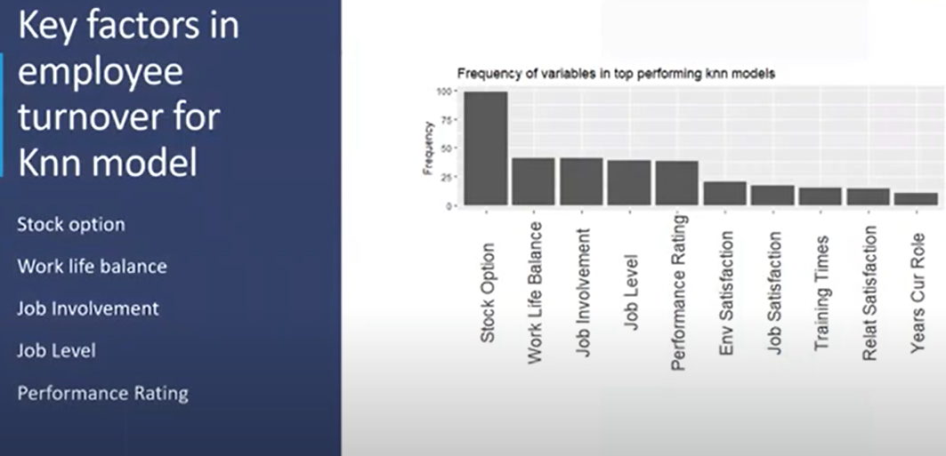

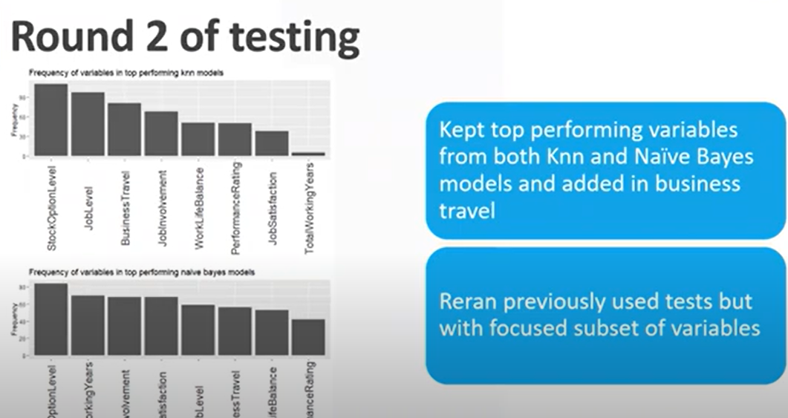

* Let’s look at the frequency of variables and top performing knn models
* By far stock option was the number one used variable in the top performing model followed by other variables
* The rest of the variables were not quite in the same order
* I took the top performance variables for both algorithms and I took out the ones the did not perform well
* The calculations were taken way too long
* I needed to narrow down the variables looked at
* It was kind of hard to come up with a complete consensus on what are the most important variables It depended by model
* By far and the clear winner is Stock option
* The rest are subjective



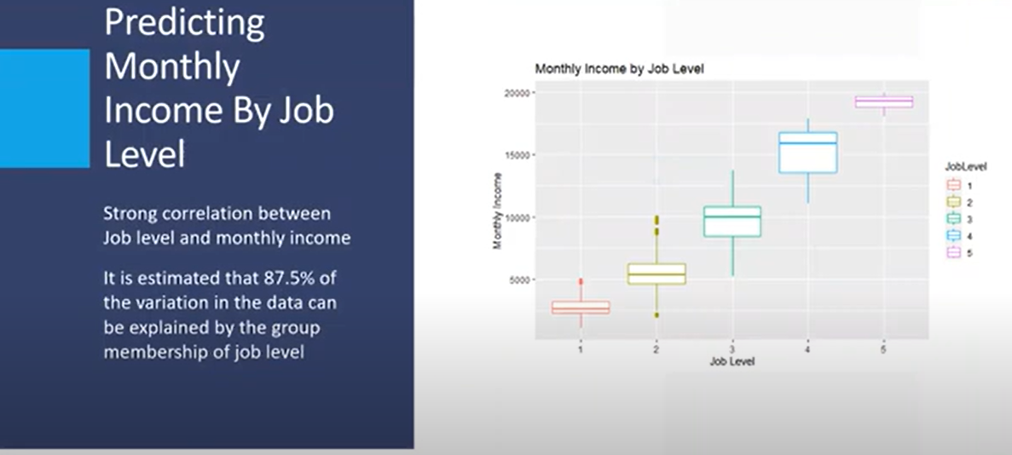

* I decided to stick with a very simple model for predicting salary
* I look at job level for how much predictive power only using job level give you
* Intuitive model and simple, very powerful



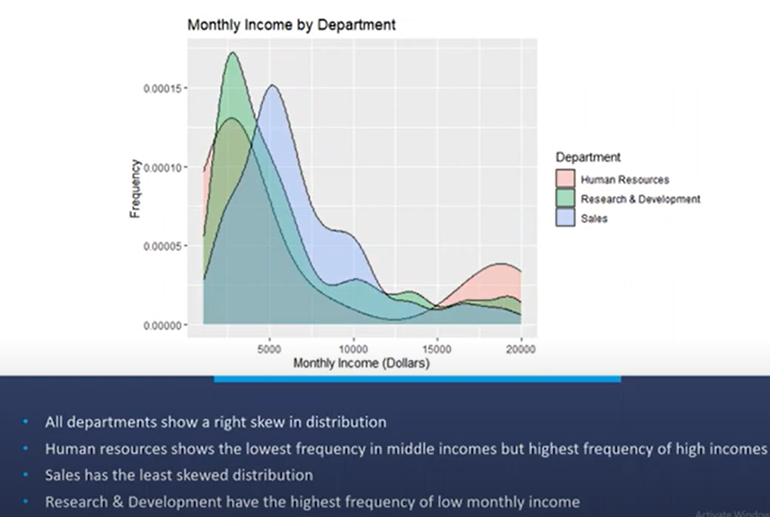

* It does an excellent job of summarizing the previous two charts we looked at
* Confirm our suspicion and out intuition about what we just have learned
* Which explain the low level

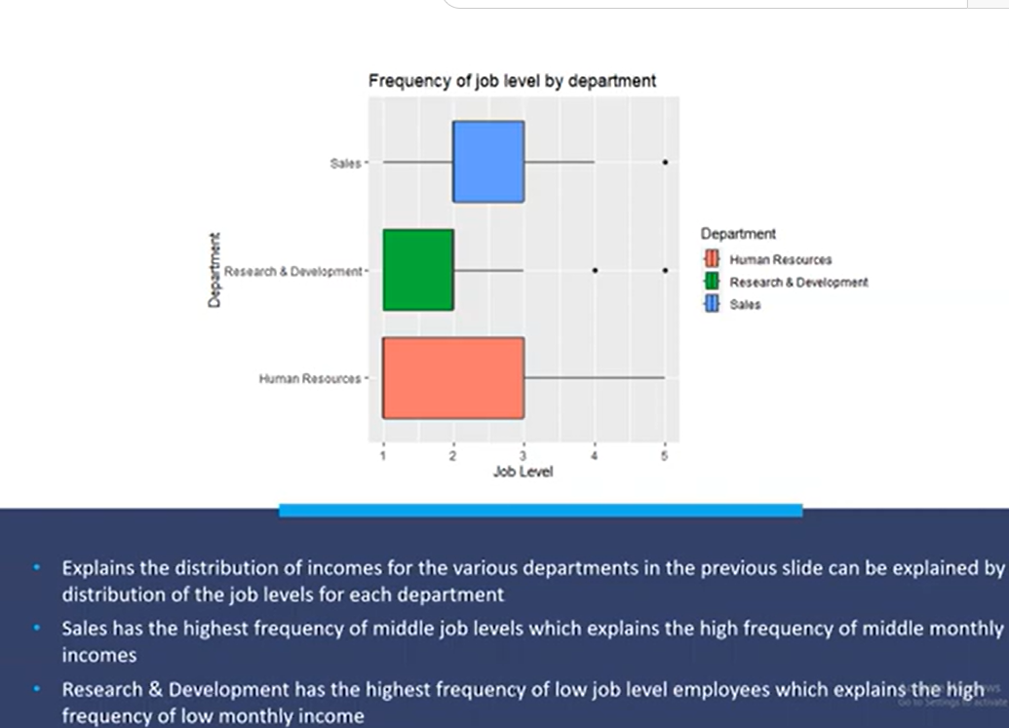



# Presentation 2



* Hi there, my name is Carlos Estevez
* Today we will be looking at attrition investigation using a dataset you provided to my company DDSAnalysis
* In this investigation we will be looking at what parameters are correlated to attrition
* Predict which employees might lead to attrition
* What your company can do to focus on minimizing attrition as much as possible within employees
* So to get started I want to set the foundations why you want to study attrition

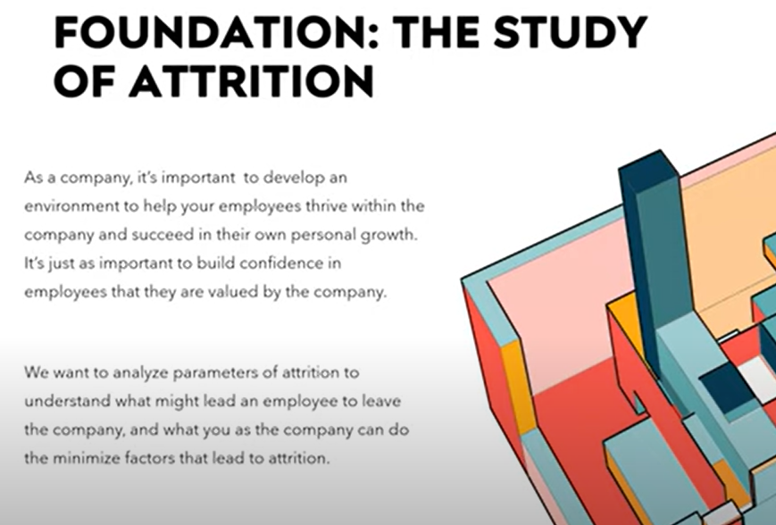

* What a company can do to minimize attrition

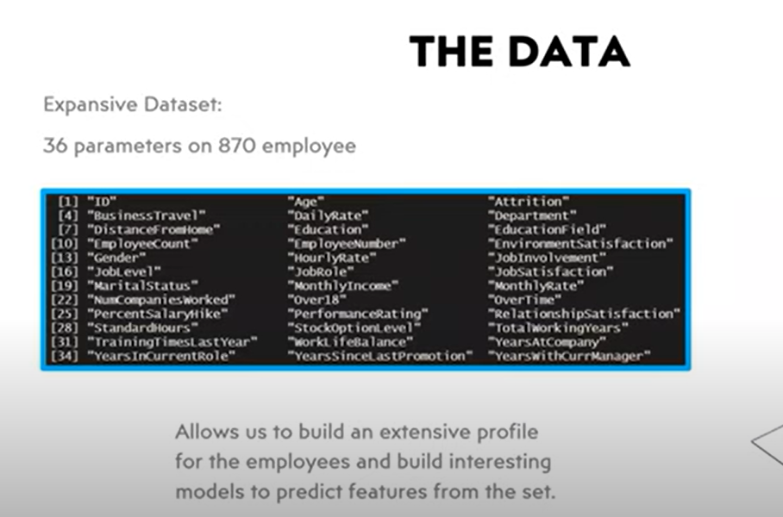

* To initiate with the investigation we had to look at the data
* The data you provided was very expansive
* A large set of parameter
* Build a lot of models to predict features

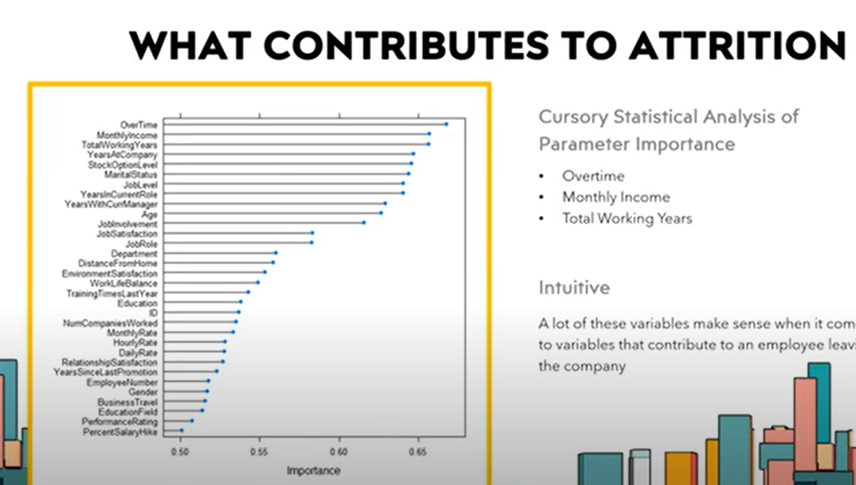

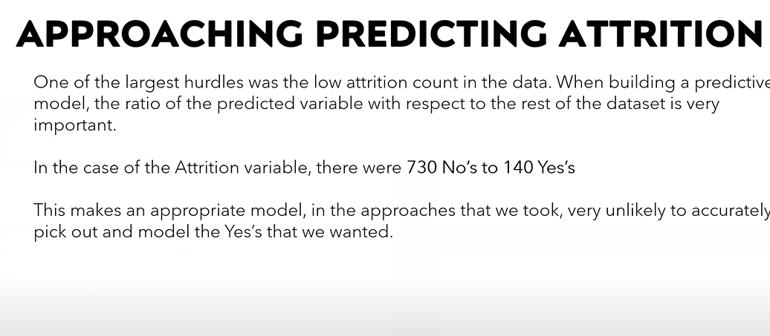

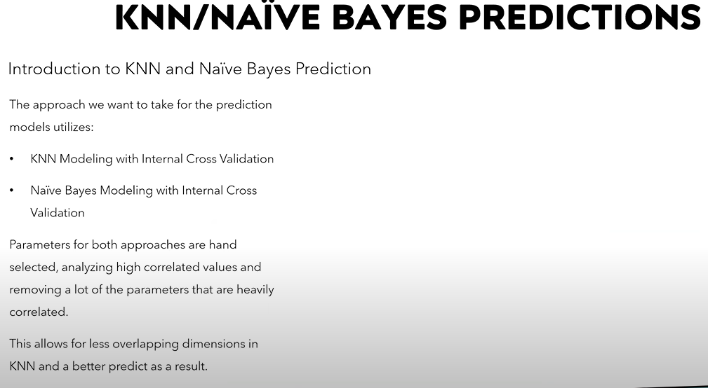

* There are two core models that we really wanted to take a look at when it came to predicting attrition
* Knn internal cross validation
* You wanted reduce as many correlated values as possible specially for KNN
* The more overlapping parameters we have the less useful our predictions will be

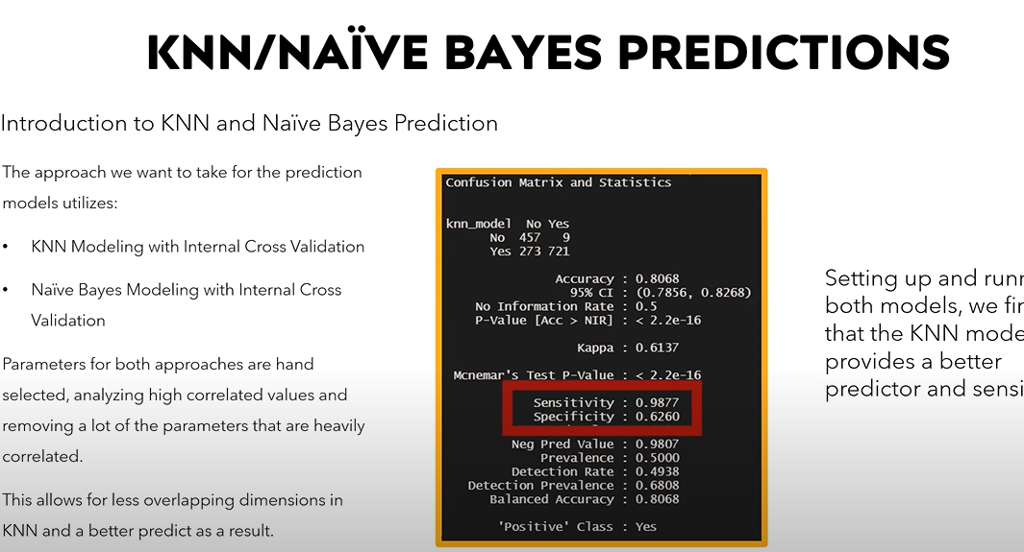

* High sensitivity for catching a lot of the Yeses



* My name is Carlos Estevez and I am a data scientist with DDSAnalytics

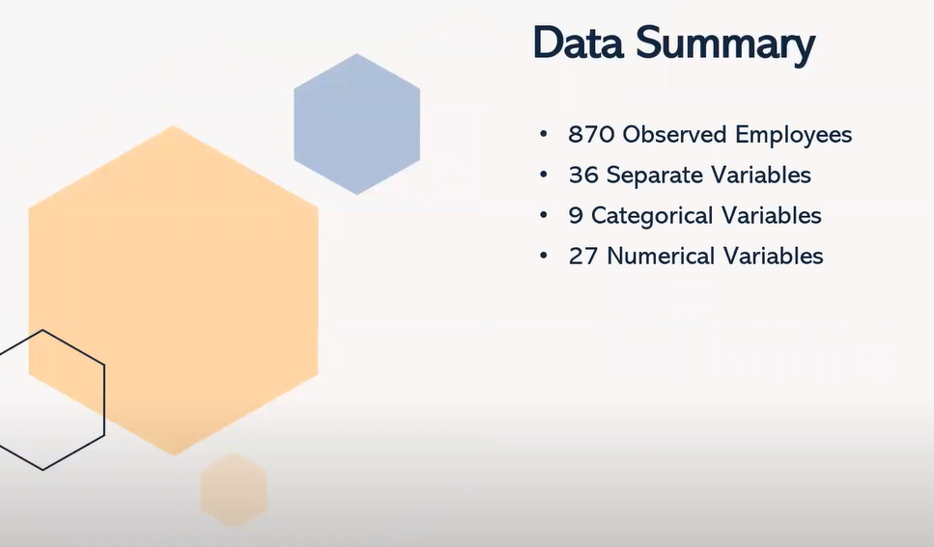



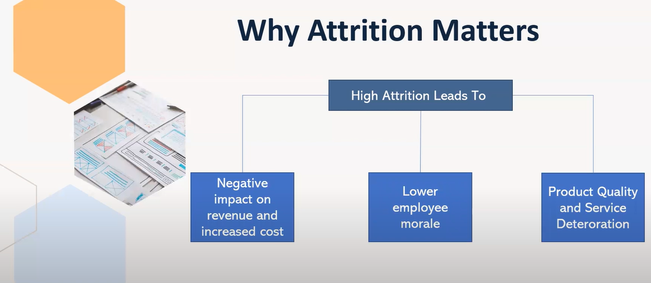

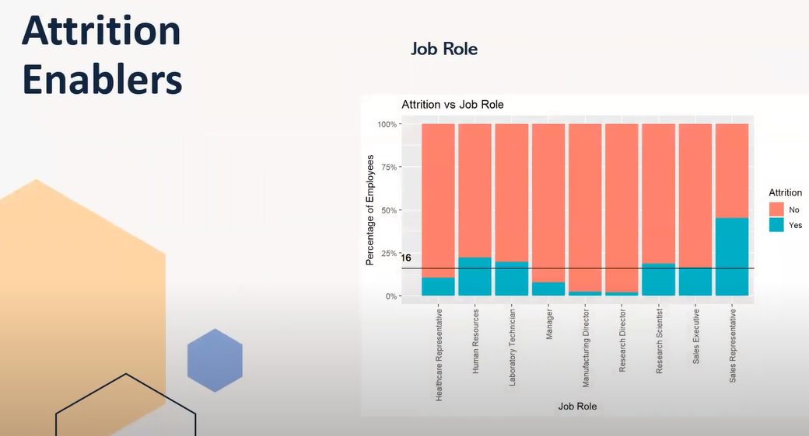

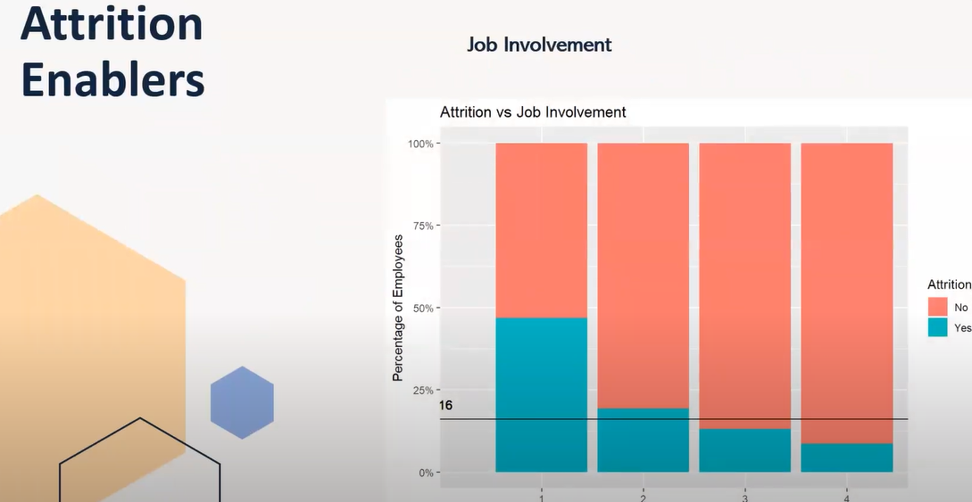

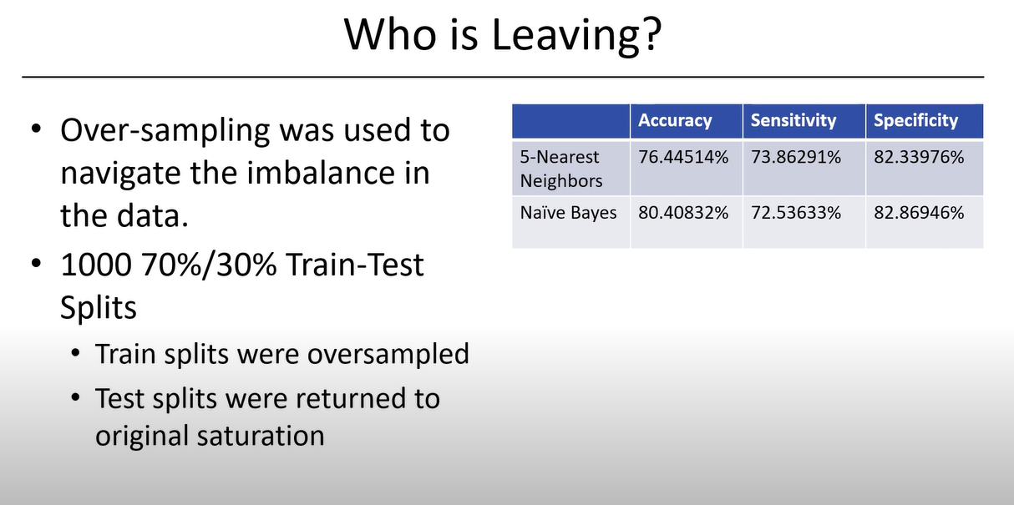

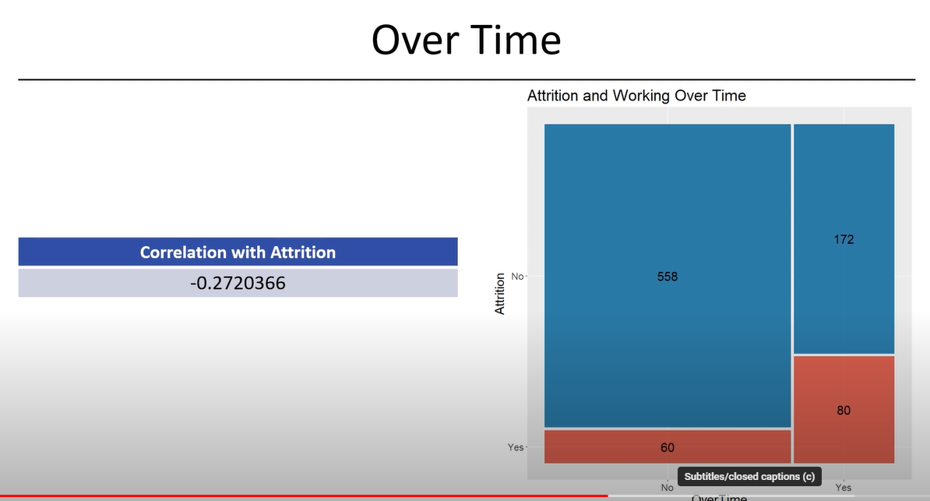

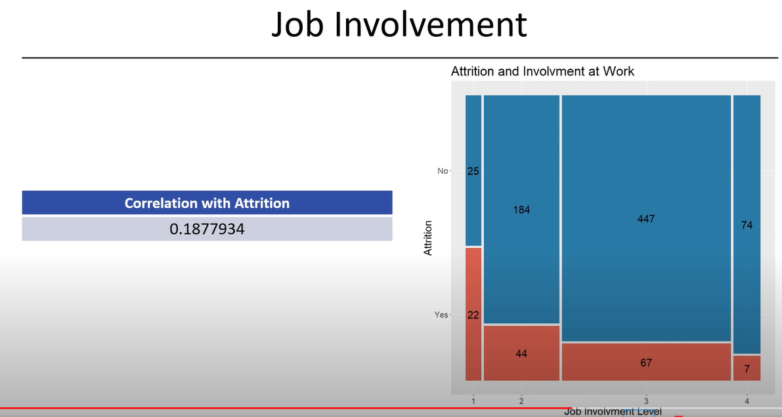

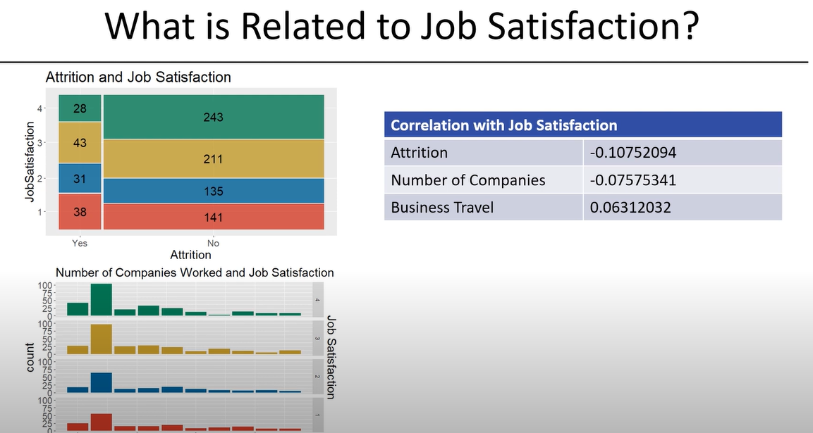

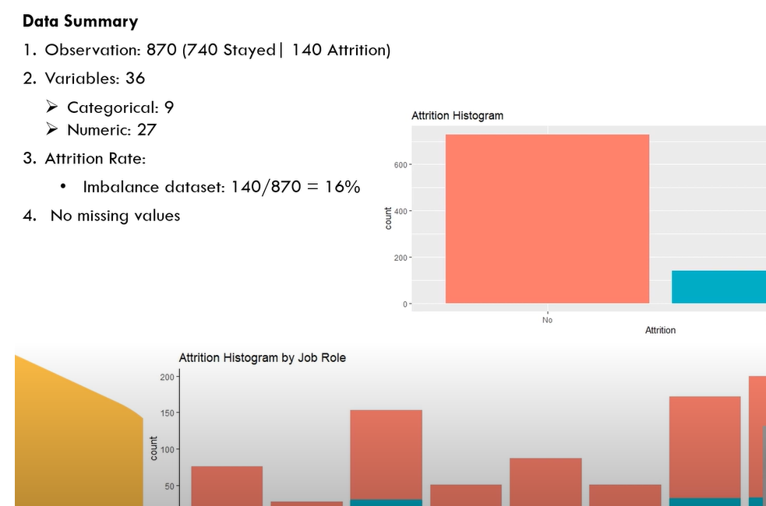

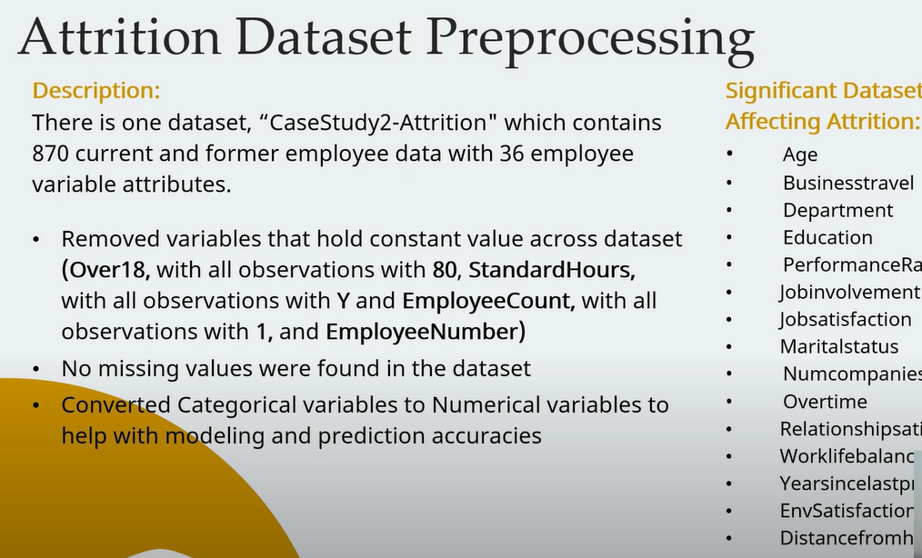

# Presentation



# Objectives

* Identify the three most important factors for Employee Attrition
* As well as build a Knn or Naïve model to predict attrition
* Build a linear regression model for predicting employee salary
* Providing insight in job role specific trends

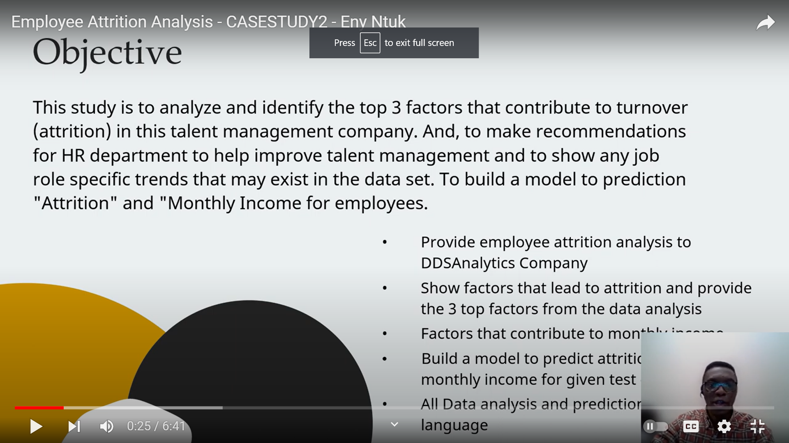

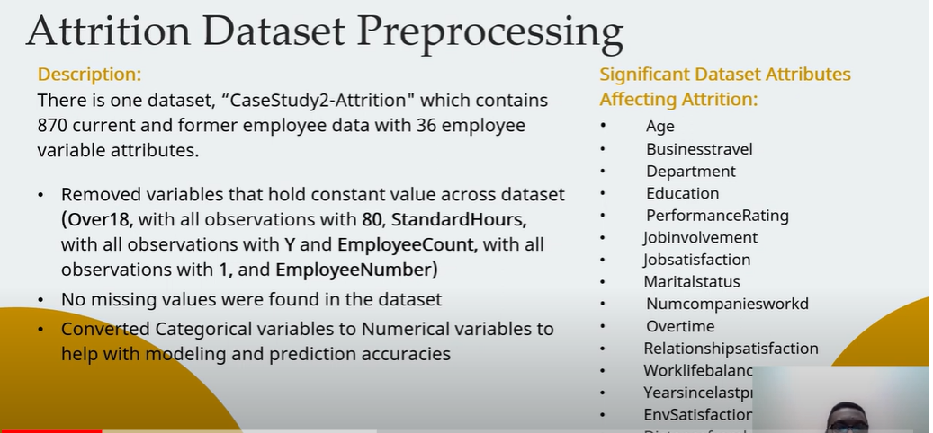

# Dataset analysis

* Number of observations
* Number of paremeters
* No missing values
* Variable importance(Correlation matrix/Chi-square test)